432 | Brain baby (0-2 years) volume | 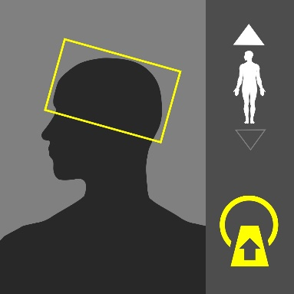
Purpose:
Evaluation of mental status changes, hydrocephalus, hemorrhages, tumors, strokes, headaches, infections, seizures, trauma, or post-operative changes.

Instructions:
Position the patient head-first. Cover the entire brain from foramen magnum to the vertex angled with the OML.
Dual Scanograms |  | 100kVp | 10mA

Patient Preparation
 | 1 | Nil by mouth for 4 hours.
 | 2 | Remove radio opaque materials in head and neck.
 | 3 | Peripheral IV – Use 24 gauge

Procedure Outline
 | 1 | Head placed in the provided head set and immobilized properly.
 | 2 | The patient should hold still during the procedure.
 | 3 | Steady normal breathing.

 | Scan Details
 | Mode | Beam | kVp | mA | Sure Exp. 3D | FOV
Pre Contrast | Volume | 0.5 | 100 | 450 | OFF | S
 | Volume/Rate: age dependent - Delay: Contrast Volume dependent
Post Contrast | Volume | 0.5 | 100 | 450 | OFF | S

 | Recon Details
 | Kernel | Thickness | Interval | Xact+ | F/H | Filters
Volume 1 | Ped. Brain | 0.5 | 0.5 | On | Full
MPR | Axial: 5.0/5.0 (Avg.) |  | Coronal 5.0/5.0(Avg.) |  | -

433 | Brain baby (3-5 years) volume | 
Purpose:
Evaluation of mental status changes, hydrocephalus, hemorrhages, tumors, strokes, headaches, infections, seizures, trauma, or post-operative changes.

Instructions:
Position the patient head-first. Cover the entire brain from foramen magnum to the vertex angled with the OML.
Dual Scanograms |  | 100kVp | 10mA

Patient Preparation
 | 1 | Nil by mouth for 4 hours.
 | 2 | Remove radio opaque materials in head and neck.
 | 3 | Peripheral IV – Use 24 gauge

Procedure Outline
 | 1 | Head placed in the provided head set and immobilized properly.
 | 2 | The patient should hold still during the procedure.
 | 3 | Steady normal breathing.

 | Scan Details
 | Mode | Beam | kVp | mA | Sure Exp. 3D | FOV
Pre Contrast | Volume | 0.5 | 120 | 400 | OFF | S
 | Volume/Rate: age dependent - Delay: Contrast Volume dependent
Post Contrast | Volume | 0.5 | 120 | 400 | OFF | S

 | Recon Details
 | Kernel | Thickness | Interval | XACT+ | F/H | Filters
Volume 1 | Ped. Brain | 0.5 | 0.5 | On | Full
MPR | Axial: 5.0/5.0 (Avg.) |  | Coronal 5.0/5.0(Avg.) |  | -

434 | Brain baby (6-12 years) volume | 
Purpose:
Evaluation of mental status changes, hydrocephalus, hemorrhages, tumors, strokes, headaches, infections, seizures, trauma, or post-operative changes.

Instructions:
Position the patient head-first. Cover the entire brain from foramen magnum to the vertex angled with the OML.
Dual Scanograms |  | 100kVp | 10mA

Patient Preparation
 | 1 | Nil by mouth for 4 hours.
 | 2 | Remove radio opaque materials in head and neck.
 | 3 | Peripheral IV – Use 24 gauge

Procedure Outline
 | 1 | Head placed in the provided head set and immobilized properly.
 | 2 | The patient should hold still during the procedure.
 | 3 | Steady normal breathing.

 | Scan Details
 | Mode | Beam | kVp | mA | Sure Exp. 3D | FOV
Pre Contrast | Volume | 0.5 | 120 | 400 | OFF | S
 | Volume/Rate: age dependent - Delay: Contrast Volume dependent
Post Contrast | Volume | 0.5 | 120 | 400 | OFF | S

 | Recon Details
 | Kernel | Thickness | Interval | XACT+ | F/H | Filters
Volume 1 | Ped. Brain | 0.5 | 0.5 | On | Full
MPR | Axial: 5.0/5.0 (Avg.) |  | Coronal 5.0/5.0(Avg.) |  | -

435 | Pediatric sinuses volume | 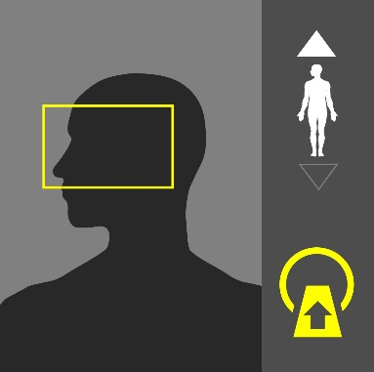
Purpose:
Evaluation of infection, polyps, tumors, trauma and surgical planning.

Instructions:
Position the patient head-first. Scan Cover from Maxillary sinuses through Frontal sinuses angled with the hard palate.
Dual Scanograms |  | 100kVp | 10mA

Patient Preparation
 | 1 | Remove radio-opaque materials from head and neck

Procedure Outline
 | 1 | Head placed in the provided head set and immobilized properly.
 | 2 | The patient should hold still during the procedure.
 | 3 | Steady normal breathing.

 | Scan Details
 | Mode | Beam | kVp | mA | Sure Exp. 3D | FOV
Pre Contrast | Volume | 0.5 | 100 | 100 | OFF | S

 | Recon Details
 | Kernel | Thickness | Interval | XACT+ | F/H | Filters
Volume 1 | Ped. Bone sharp | 0.5 | 0.5 | On | Full
MPR | Axial: 1.0/1.0 (Avg.) |  | Coronal 1.0/1.0(Avg.) |  | -
Volume 2 | Ped. body | 0.5 | 0.5 | On | Full
MPR | Axial: 1.0/1.0 (Avg.) |  | Coronal 1.0/1.0(Avg.) |  | -

436 | IAM CHILD volume | 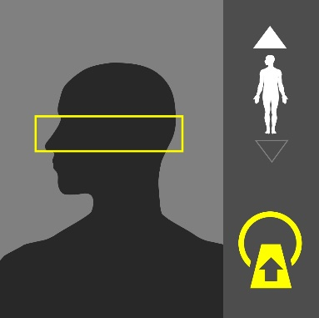
Purpose:
evaluation of infection, tumors and congenital abnormalities of the external auditory canal, middle ear, inner ear, internal auditory canal and course of 7th cranial nerve.

Instructions:
Position the patient head-first. Scan Cover from mastoid tip and finish at the top of petrous bone.
Dual Scanograms |  | 100kVp | 10mA

Patient Preparation
 | 1 | Remove radio-opaque materials from head and neck

Procedure Outline
 | 1 | Head placed in the provided head set and immobilized properly.
 | 2 | The patient should hold still during the procedure.
 | 3 | Steady normal breathing.

 | Scan Details
 | Mode | Beam | kVp | mA | Sure Exp. 3D | FOV
Pre Contrast | Volume | 0.5 | 100 | 150 | OFF | S

 | Recon Details
 | Kernel | Thickness | Interval | XACT+ | F/H | Filters
Volume 1 | Ped. Bone Sharp | 0.5 SR | 0.5 | On | Full
MPR | Axial: 0.5/0.5 (Avg.) |  | Coronal 0.5/0.5(Avg.) |  | ---

480 | Neck Child < 15 kg (Volume) | 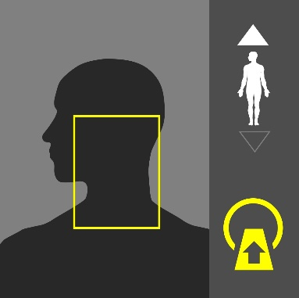
Purpose:
evaluation of Tumors, vocal cords condition, abscesses, cysts and salivary glands
Instructions:
Position the patient head-first. Scan cover from the Thoracic inlet to the skull base.
Dual Scanograms |  | 80kVp | 10mA

Patient Preparation
 | 1 | Nil by mouth for 4 hours.
 | 2 | Remove radio opaque materials in head and neck.
 | 3 | Peripheral IV – Use 24 gauge

Procedure Outline
 | 1 | Head placed in the provided head set and immobilized properly.
 | 2 | The patient should hold still during the procedure.
 | 3 | Steady normal breathing.

 | Scan Details
 | Mode | Beam | kVp | mA | Sure Exp. 3D | FOV
Pre Contrast | Volume | 0.5 | 80 | R*** | <15 kg | S
 | Volume/Rate: age dependent - Delay: Contrast Volume dependent
Post Contrast | Volume | 0.5 | 80 | R*** | <15 kg | S

 | Recon Details
 | Kernel | Thickness | Interval | XACT+ | F/H | Filters
Volume 1 | Ped. Neck | 0.5 | 0.5 | On | Full
MPR | Axial: 2.0/2.0 (Avg.) |  | Coronal: 2.0/2.0 (Avg.) |  | Sagittal: 2.0/2.0 (Avg.)
Volume 2 | Ped. Bone Sharp | 0.5 | 0.5 | On | Full
MPR | A Axial: 2.0/2.0 (Avg.) |  | Coronal: 2.0/2.0 (Avg.) |  | Sagittal: 2.0/2.0 (Avg.)

481 | Neck Child 16-30 kg (Volume) | 
Purpose:
evaluation of Tumors, vocal cords condition, abscesses, cysts and salivary glands
Instructions:
Position the patient head-first. Scan cover from the Thoracic inlet to the skull base.
Dual Scanograms |  | 100kVp | 10mA

Patient Preparation
 | 1 | Nil by mouth for 6 hours.
 | 2 | Remove radio opaque materials in head and neck.
 | 3 | Peripheral IV – Use 24 gauge

Procedure Outline
 | 1 | Ensure the Patient positioned properly by neck holder.
 | 2 | Maintain patient’s positon through the procedure.
 | 3 | Steady normal breathing.

 | Scan Details
 | Mode | Beam | kVp | mA | Sure Exp. 3D | FOV
Pre Contrast | Volume | 0.5 | 100 | R*** | 16-30 kg | S
 | Volume/Rate: age dependent - Delay: Contrast Volume dependent
Post Contrast | Volume | 0.5 | 100 | R*** | 16-30 kg | S

 | Recon Details
 | Kernel | Thickness | Interval | XACT+ | F/H | Filters
Volume 1 | Ped. Neck | 0.5 | 0.5 | On | Full
MPR | Axial: 2.0/2.0 (Avg.) |  | Coronal: 2.0/2.0 (Avg.) |  | Sagittal: 2.0/2.0 (Avg.)
Volume 2 | Ped. Bone Sharp | 0.5 | 0.5 | On | Full
MPR | Axial: 2.0/2.0 (Avg.) |  | - |  | -

482 | Neck Child 31-45 kg (HCT) | 
Purpose:
evaluation of Tumors, vocal cords condition, abscesses, cysts and salivary glands
Instructions:
Position the patient head-first. Scan cover from the Thoracic inlet to the skull base.
Dual Scanograms |  | 100kVp | 10mA
Patient Preparation
 | 1 | Nil by mouth for 6 hours.
 | 2 | Remove radio opaque materials in head and neck.
 | 3 | Peripheral IV Use (22-20) gauge Depend on the child weight.

Procedure Outline
 | 1 | Nil by mouth for 8 hours.
 | 2 | Remove radio opaque materials in head and neck.
 | 3 | Peripheral IV – Use 20 gauge

 | Scan Details
 | Mode | Beam | kVp | mA | Sure Exp. 3D | FOV
Pre Contrast | Helical | 0.5X80 | 100 | R*** | 31-45 kg | S
 | Volume/Rate: age dependent - Delay: Contrast Volume dependent
Post Contrast | Helical | 0.5X80 | 100 | R*** | 31-45 kg | S

 | Recon Details
 | Kernel | Thickness | Interval | XACT+ | F/H | Filters
Volume 1 | Ped. Neck | 0.5 | 0.3 | - | -
MPR | Axial: 2.0/2.0 (Avg.) |  | Coronal: 2.0/2.0 (Avg.) |  | Sagittal: 2.0/2.0 (Avg.)
Axial 1 | Ped. NECK | 2.0 | 2.0 | - | - | -
Axial 2 | Ped. Bone Sharp | 2.0 | 2.0 | - | - | -
483 | Neck Child 45-60 kg (HCT) | 
Purpose:
evaluation of Tumors, vocal cords condition, abscesses, cysts and salivary glands
Instructions:
Position the patient head-first. Scan cover from the Thoracic inlet to the skull base.
Dual Scanograms |  | 120kVp | 10mA

Patient Preparation
 | 1 | Nil by mouth for 8 hours.
 | 2 | Remove radio opaque materials in head and neck.
 |  | Peripheral IV – Use 24 gauge

Procedure Outline
 | 1 | Ensure the Patient positioned properly by neck holder.
 | 2 | Maintain patient’s positon through the procedure.
 | 3 | Steady normal breathing.

 | Scan Details
 | Mode | Beam | kVp | mA | Sure Exp. 3D | FOV
Pre Contrast | Helical | 0.5X80 | 120 | R*** | 46-60 kg | S
 | Volume/Rate: age dependent - Delay: Contrast Volume dependent
Post Contrast | Helical | 0.5X80 | 120 | R*** | 46-60 kg | S

 | Recon Details
 | Kernel | Thickness | Interval | XACT+ | F/H | Filters
Volume 1 | Ped. Neck | 0.5 | 0.3 | - | -
MPR | Axial: 2.0/2.0 (Avg.) |  | Coronal: 2.0/2.0 (Avg.) |  | Sagittal: 2.0/2.0 (Avg.)
Axial 1 | Ped. NECK | 2.0 | 2.0 | - | - | -
Axial 2 | Ped. Bone Sharp | 2.0 | 2.0

484 | Neck Child 61 kg (HCT) | 
Purpose:
evaluation of Tumors, vocal cords condition, abscesses, cysts and salivary glands
Instructions:
Position the patient head-first. Scan cover from the Thoracic inlet to the skull base.
Dual Scanograms |  | 120kVp | 10mA

Patient Preparation
 | 1 | Nil by mouth for 8 hours.
 | 2 | Remove radio opaque materials in head and neck.
 | 3 | Peripheral IV – Use 20 gauge

Procedure Outline
 | 1 | Ensure the Patient positioned properly by neck holder.
 | 2 | Maintain patient’s positon through the procedure.
 | 3 | Steady normal breathing.

 | Scan Details
 | Mode | Beam | kVp | mA | Sure Exp. 3D | FOV
Pre Contrast | Helical | 0.5X80 | 120 | R*** | 61+ kg | S
 | Volume/Rate: age dependent - Delay: Contrast Volume dependent
Post Contrast | Helical | 0.5X80 | 120 | R*** | 61+ kg | S

 | Recon Details
 | Kernel | Thickness | Interval | XACT+ | F/H | Filters
Volume 1 | Ped. Neck | 0.5 | 0.3 | - | -
MPR | Axial: 2.0/2.0 (Avg.) |  | Coronal: 2.0/2.0 (Avg.) |  | Sagittal: 2.0/2.0 (Avg.)
Axial 1 | Ped. NECK | 2.0 |  | - | - | -
Axial 2 | Ped. Bone Sharp | 2.0

528 | Chest baby <15 kg (HCT) | 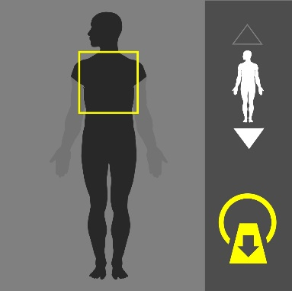
Purpose:
Screen for widespread disease of lymphoma, metastatic disease, trauma, pneumonia, pleural effusion, pneumothorax or pneumonia.
Instructions:
Position the patient supine arm up, feet first. Scan Cover the entire thorax.
Dual Scanograms |  | 80kVp | 20mA

Patient Preparation
 | 1 | Nil by mouth for 4 hours.
 | 2 | Remove radio opaque materials in neck and chest.
 | 3 | Peripheral IV – Use (24-22) gauge Depend on the baby weight.

Procedure Outline
 | 1 | Ensure the Patient positioned properly. (Feet first –arms up to the head).
 | 2 | Breathing instruction is required for the examination. (Full inspiration).
 | 3 | No movement during the procedure.

 | Scan Details
 | Mode | Beam | kVp | mA | Sure Exp. 3D | FOV
Pre Contrast | Volume | 0.5 | 80 | R*** | <15 kg | S
 | Volume/Rate: age dependent - Delay: Contrast Volume dependent
Post Contrast | Volume | 0.5 | 80 | R*** | <15 kg | S

 | Recon Details
 | Kernel | Thickness | Interval | XACT+ | F/H | Filters
Volume 1 | Ped. Body | 0.5 | 0.5 | On | Full | -
MPR | Axial: 2.0/2.0 (Avg.) |  | Coronal: 2.0/2.0 (Avg.)
VOLUME 2 | Ped. Lung | 0.5 | 0.5 | On | Full | -
MPR | Axial: 2.0/2.0 (Avg.) |  | Coronal: 2.0/2.0 (Avg.)

529 | Chest Child 16-30 kg (HCT) | 
Purpose:
Screen for widespread disease of lymphoma, metastatic disease, trauma, pneumonia, pleural effusion, pneumothorax or pneumonia.
Instructions:
Position the patient supine arm up, feet first. Scan Cover the entire thorax.
Dual Scanograms |  | 100kVp | 20mA

Patient Preparation
 | 1 | Nil by mouth for 6 hours.
 | 2 | Remove radio opaque materials in head and neck.
 | 3 | Peripheral IV – Use (22-20) gauge Depend on the child weight.

Procedure Outline
 | 1 | Ensure the Patient positioned properly (Feet first –arms up to the head).
 | 2 | Breathing instruction is required for the examination. (full inspiration)
 | 3 | No movement during the procedure.

 | Scan Details
 | Mode | Beam | kVp | mA | Sure Exp. 3D | FOV
Pre Contrast | Helical | 0.5X80 | 100 | R*** | 16-30 kg | S
 | Volume/Rate: age dependent - Delay: Contrast Volume dependent
Post Contrast | Helical | 0.5X80 | 100 | R*** | 16-30 kg | S

 | Recon Details
 | Kernel | Thickness | Interval | XACT+ | F/H | Filters
Volume 1 | Ped. Body | 0.5 | 0.3 | - | - | -
MPR |  |  | Coronal: 3.0/3.0 (Avg.)
Axial 1 | Ped. Body | 3.0 | 3.0 | - | - | -
Axial 2 | Ped. Lung | 3.0 | 3.0

530 | Chest Child 31-45 kg (HCT) | 
Purpose:
Screen for widespread disease of lymphoma, metastatic disease, trauma, pneumonia, pleural effusion, pneumothorax or pneumonia.
Instructions:
Position the patient supine arm up, feet first. Scan Cover the entire thorax.
Dual Scanograms |  | 100kVp | 20mA

Patient Preparation
 | 1 | Nil by mouth for 6 hours.
 | 2 | Remove radio opaque materials in neck and chest.
 | 3 | Peripheral IV – Use (22-20) gauge. Depend on child weight.

Procedure Outline
 | 1 | Ensure the Patient positioned properly (Feet first –arms up to the head).
 | 2 | Breathing instruction is required for the examination. (Full inspiration).
 | 3 | No movement during the procedure.

 | Scan Details
 | Mode | Beam | kVp | mA | Sure Exp. 3D | FOV
Pre Contrast | Helical | 0.5X80 | 100 | R*** | 31-45 kg | S
 | Volume/Rate: age dependent - Delay: Contrast Volume dependent
Post Contrast | Helical | 0.5X80 | 100 | R*** | 31-45 kg | S

 | Recon Details
 | Kernel | Thickness | Interval | XACT+ | F/H | Filters
Volume 1 | Ped. Body | 0.5 | 0.3 | - | - | -
MPR | - |  | Coronal: 3.0/3.0 (Avg.) |  | -
Axial 1 | Ped. Body | 3.0 | 3.0 | - | - | -
Axial 2 | Ped. Lung | 3.0 | 3.0 | - | - | -

531 | Chest Child 46-60 kg (HCT) | 
Purpose:
Screen for widespread disease of lymphoma, metastatic disease, trauma, pneumonia, pleural effusion, pneumothorax or pneumonia.
Instructions:
Position the patient supine arm up, feet first. Scan Cover the entire thorax.
Dual Scanograms |  | 120kVp | 20mA

Patient Preparation
 | 1 | Nil by mouth for 8 hours.
 | 2 | Remove radio opaque materials in neck and chest.
 | 3 | Peripheral IV – Use (22- 20) gauge. Depend on child weight.

Procedure Outline
 | 1 | Ensure the Patient positioned properly. (Feet first –arms up to the head).
 | 2 | Breathing instruction is required for the examination. (Full inspiration).
 | 3 | No movement during the procedure.

 | Scan Details
 | Mode | Beam | kVp | mA | Sure Exp. 3D | FOV
Pre Contrast | Helical | 0.5X80 | 120 | R*** | 46-60 kg | M
 | Volume/Rate: age dependent - Delay: Contrast Volume dependent
Post Contrast | Helical | 0.5X80 | 120 | R*** | 46-60 kg | M

 | Recon Details
 | Kernel | Thickness | Interval | XACT+ | F/H | Filters
Volume 1 | Ped. Body | 0.5 | 0.3 | - | - | -
MPR | - |  | Coronal: 3.0/3.0 (Avg.) |  | -
Axial 1 | Ped. Body | 3.0 | 3.0 | - | - | -
Axial 2 | Ped. Lung | 3.0 | 3.0 | - | - | -

532 | Chest Child 60+ kg (HCT) | 
Purpose:
Screen for widespread disease of lymphoma, metastatic disease, trauma, pneumonia, pleural effusion, pneumothorax or pneumonia.
Instructions:
Position the patient supine arm up, feet first. Scan Cover the entire thorax.
Dual Scanograms |  | 120kVp | 20mA

Patient Preparation
 | 1 | Nil by mouth for 8 hours.
 | 2 | Remove radio opaque materials in neck and chest.
 | 3 | Peripheral IV – Use 20 gauge

Procedure Outline
 | 1 | Breathing instruction is required for the examination. (Full inspiration).
 | 2 | No movement during the procedure.

 | Scan Details
 | Mode | Beam | kVp | mA | Sure Exp. 3D | FOV
Pre Contrast | Helical | 0.5X80 | 120 | R*** | 60 + kg | M
 | Volume/Rate: age dependent - Delay: Contrast Volume dependent
Post Contrast | Helical | 0.5X80 | 120 | R*** | 60 + kg | M

 | Recon Details
 | Kernel | Thickness | Interval | XACT+ | F/H | Filters
Volume 1 | Ped. Body | 0.5 | 0.3 | - | - | -
MPR | Axial: 3.0/3.0 (Avg.) |  | Coronal: 3.0/3.0 (Avg.)
Axial 1 | Ped. Body | 3.0 | 3.0 | - | - | -
Axial 2 | Ped. Lung | 3.0 | 3.0 | - | - | -

576 | Abdomen Baby <15 kg (Volume) | 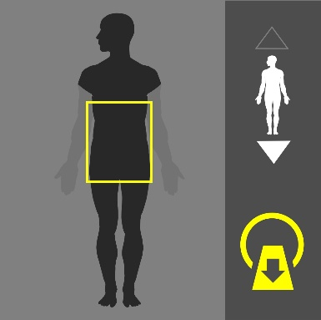
Purpose:
Abdomen pain, trauma, bowel obstruction, complication of hernia pancreatitis, acute vascular compromise, abdominal aneurysm.
Instructions:
Position the patient supine arm up, feet first. Scan Cover the entire abdomen (from diaphragm to symphysis pubis).
Dual Scanograms |  | 80kVp | 20mA

Patient Preparation
 | 1 | Nil by mouth for 4 hours.
 | 2 | Remove radio opaque materials in chest, abdomen and pelvis.
 |  | Peripheral IV - Use 24 gauge

Procedure Outline
 | 1 | Head placed in the provided head set and immobilized properly. (Feet first –arms up to the head).
 | 2 | The patient should hold still during the procedure.
 | 3 | Steady normal breathing.

 | Scan Details
 | Mode | Beam | kVp | mA | Sure Exp. 3D | FOV
Pre Contrast | Volume | 0.5 | 80 | R*** | <15 kg | S
 | Volume/Rate: age dependent - Delay: Contrast Volume dependent
Post Contrast | Volume | 0.5 | 80 | R*** | <15 kg | S

 | Recon Details
 | Kernel | Thickness | Interval | XACT+ | F/H | Filters
Volume 1 | Ped. Body | 0.5 | 0.5 | On | Full | -
MPR | Axial: 2.0/2.0 (Avg.) |  | Coronal: 2.0/2.0 (Avg.) |  | -

577 | Abdomen Child 16-30 kg (HCT) | 
Purpose:
Abdomen pain, trauma, bowel obstruction, complication of hernia pancreatitis, acute vascular compromise, abdominal aneurysm.
Instructions:
Position the patient supine arm up, feet first. Scan Cover the entire abdomen (from diaphragm to symphysis pubis).
Dual Scanograms |  | 100kVp | 20mA

Patient Preparation
 | 1 | Nil by mouth for 6 hours.
 | 2 | Remove radio opaque materials in chest, abdomen and pelvis.
 | 3 | Peripheral IV - Use 22 gauge depend on child weight.
 | 4 | If oral contrast is required, please refer to the “Oral Contrast” section for detailed instructions

Procedure Outline
 | 1 | Head placed in the provided head set and immobilized properly. (Feet first –arms up to the head).
 | 2 | The patient should hold still during the procedure.
 | 3 | Steady normal breathing.

 | Scan Details
 | Mode | Beam | kVp | mA | Sure Exp. 3D | FOV
Pre Contrast | Helical | 0.5X80 | 100 | R*** | 16-30 kg | S
 | Volume/Rate: age dependent - Delay: Contrast Volume dependent
Post Contrast | Helical | 0.5X80 | 100 | R*** | 16-30 kg | S

 | Recon Details
 | Kernel | Thickness | Interval | XACT+ | F/H | Filters
Volume 1 | Ped. Body | 0.5 | 0.3 | - | - | -
MPR | Axial: 3.0/3.0 (Avg.) |  | Coronal: 3.0/3.0 (Avg.)
Axial 1 | Ped. Body | 3.0 | 3.0 | - | - | -

578 | Abdomen Child 31-45 (HCT) | 
Purpose:
Abdomen pain, trauma, bowel obstruction, complication of hernia pancreatitis, acute vascular compromise, abdominal aneurysm.
Instructions:
Position the patient supine arm up, feet first. Scan Cover the entire abdomen (from diaphragm to symphysis pubis).
Dual Scanograms |  | 100kVp | 20mA

Patient Preparation
 | 1 | Nil by mouth for 8 hours.
 | 2 | Remove radio opaque materials in chest, abdomen and pelvis.
 | 3 | Peripheral IV - Use (22-20) gauge depend on child weight.
 | 4 | If oral contrast is required, please refer to the “Oral Contrast” section for detailed instructions

Procedure Outline
 | 1 | Head placed in the provided head set and immobilized properly. (Feet first –arms up to the head).
 | 2 | The patient should hold still during the procedure.
 | 3 | Steady normal breathing.

 | Scan Details
 | Mode | Beam | kVp | mA | Sure Exp. 3D | FOV
Pre Contrast | Helical | 0.5X80 | 100 | R*** | 31-45 kg | S
 | Volume/Rate: age dependent - Delay: Contrast Volume dependent
Post Contrast | Helical | 0.5X80 | 100 | R*** | 31-45 kg | S

 | Recon Details
 | Kernel | Thickness | Interval | XACT+ | F/H | Filters
Volume 1 | Ped. Body | 0.5 | 0.3 | - | - | -
MPR |  |  | Coronal: 3.0/3.0 (Avg.)
Axial 1 | Ped. Body |  | 3.0 |  | 3.0

579 | Abdomen 46-60 (HCT) | 
Purpose:
Abdomen pain, trauma, bowel obstruction, complication of hernia pancreatitis, acute vascular compromise, abdominal aneurysm.
Instructions:
Position the patient supine arm up, feet first. Scan Cover the entire abdomen (from diaphragm to symphysis pubis).
Dual Scanograms |  | 120kVp | 20mA

Patient Preparation
1 | Nil by mouth for 8 hours.
2 | Remove radio opaque materials in chest, abdomen and pelvis.
3 | Peripheral IV - Use 20 gauge.
4 | If oral contrast is required, please refer to the “Oral Contrast” section for detailed instructions

Procedure Outline
 | 1 | Ensure the Patient positioned properly. (Feet first –arms up to the head).
 | 2 | Breathing instruction is required for the examination. (full inspiration)
 | 3 | No movement during the procedure.

 | Scan Details
 | Mode | Beam | kVp | mA | Sure Exp. 3D | FOV
Pre Contrast | Helical | 0.5X80 | 120 | R*** | 46-60 kg | M
 | Volume/Rate: age dependent - Delay: Contrast Volume dependent
Post Contrast | Helical | 0.5X80 | 120 | R*** | 46-60 kg | M

 | Recon Details
 | Kernel | Thickness | Interval | XACT+ | F/H | Filters
Volume 1 | Ped. Body | 0.5 | 0.3 | - | - | -
MPR |  |  | Coronal: 3.0/3.0 (Avg.)
Axial 1 | Ped. Body |  | 3.0 |  | 3.0

580 | Abdomen Child 61+ kg (HCT) | 
Purpose:
Abdomen pain, trauma, bowel obstruction, complication of hernia pancreatitis, acute vascular compromise, abdominal aneurysm.
Instructions:
Position the patient supine arm up, feet first. Scan Cover the entire abdomen (from diaphragm to symphysis pubis).
Dual Scanograms |  | 120kVp | 20mA

Patient Preparation
 | 1 | Nil by mouth for 8 hours.
 | 2 | Remove radio opaque materials in neck and chest.
 | 3 | Peripheral IV – Use 20 gauge.
 | 4 | If oral contrast is required, please refer to the “Oral Contrast” section for detailed instructions

Procedure Outline
 | 1 | Head placed in the provided head set and immobilized properly. (Feet first –arms up to the head).
 | 2 | The patient should hold still during the procedure. (full inspiration)
 | 3 | No movement during the procedure.

 | Scan Details
 | Mode | Beam | kVp | mA | Sure Exp. 3D | FOV
Pre Contrast | Helical | 0.5X80 | 120 | R*** | 60 + kg | M
 | Volume/Rate: age dependent - Delay: Contrast Volume dependent
Post Contrast | Helical | 0.5X80 | 120 | R*** | 60 + kg | M

 | Recon Details
 | Kernel | Thickness | Interval | XACT+ | F/H | Filters
Volume 1 | Ped. Body | 0.5 | 0.3 | - | - | -
MPR | Axial: 3.0/3.0 (Avg.) |  | Coronal: 3.0/3.0 (Avg.)
Axial 1 | Ped. Body |  | 3.0 |  | 3.0

672 | Extremity <15 | 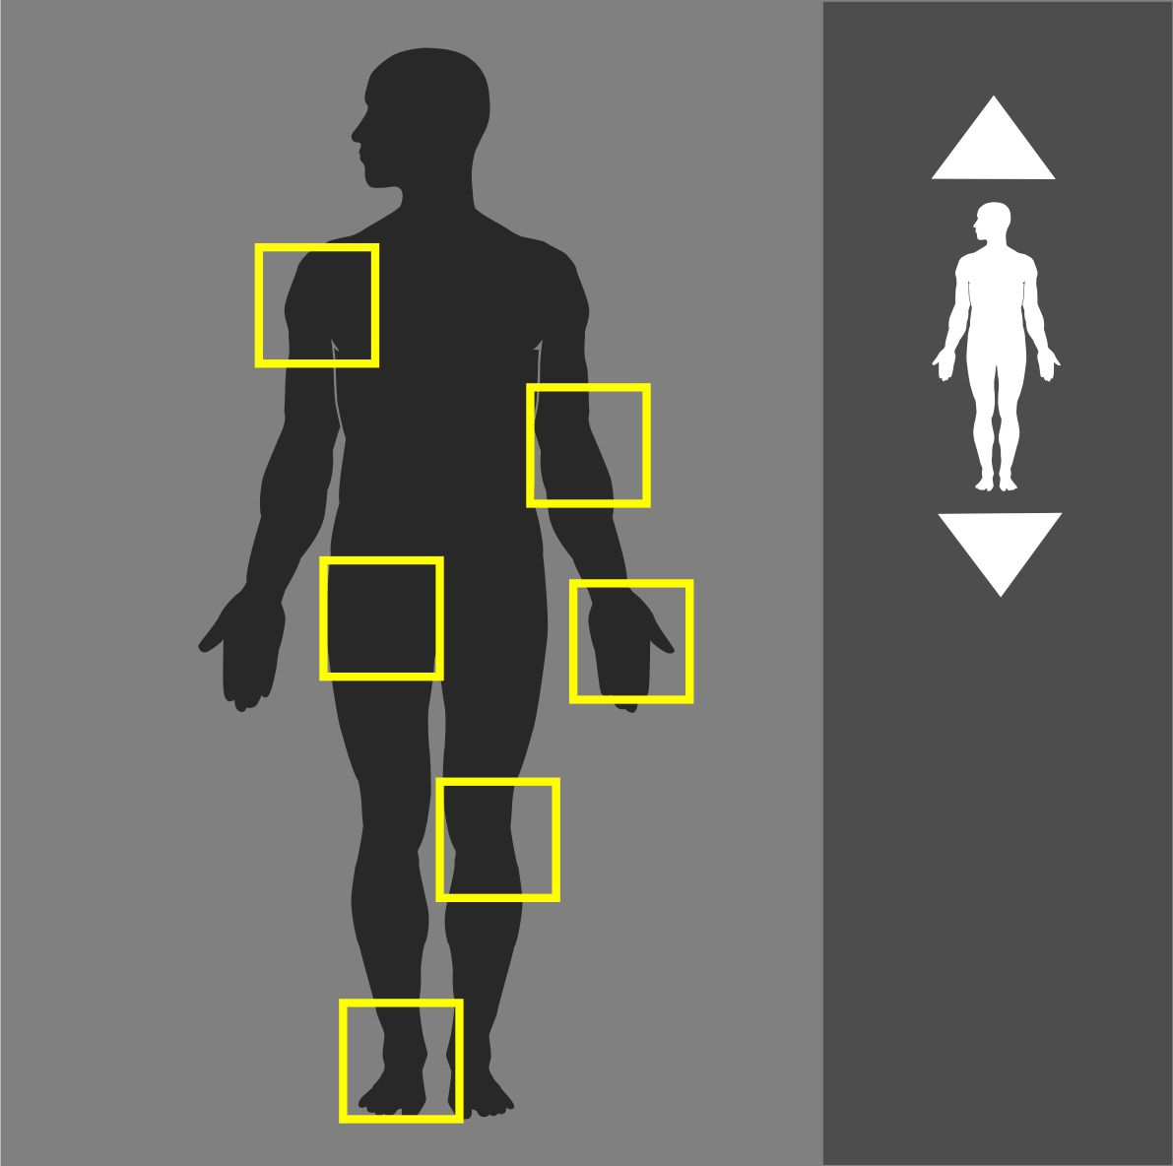
Purpose:
Evaluation of trauma and injuries, query of bone pathologies.

Instructions:
The extremity of interest should be covered for the examination.
Dual Scanograms |  | 80kVp | 20mA

Patient Preparation
 | 1 | Remove radio opaque materials.

Procedure Outline
 | 1 | Ensure the Patient positioned properly.
 | 2 | Breathing instruction is not required for the examination.
 | 3 | No movement during the procedure.

 | Scan Details
 | Mode | Beam | kVp | mA | Sure Exp. 3D | FOV
Pre Contrast | Volume | 0.5 | 80 | 80 | Off | S
 | Volume/Rate: age dependent - Delay: Contrast Volume dependent
Post Contrast | Volume | 0.5 | 80 | 80 | Off | S

 | Recon Details
 | Kernel | Thickness | Interval | XACT+ | F/H | Filters
Volume 1 | Ped. Bone Sharp | 0.5 | 0.5 | On | Full | -
MPR | Axial: 2.0/2.0 (Avg.) |  | Coronal: 2.0/2.0 (Avg.) |  | Sagittal:2.0/2.0
Volume 2 | Soft Tissue Sharp | 0.5 | 0.5 | On | Full | -
MPR | Axial: 2.0/2.0 (Avg.) |  | Coronal: 2.0/2.0 (Avg.) |  | Sagittal:2.0/2.0

673 | Extremity 15-35 kg | 
Purpose:
Evaluation of trauma and injuries, query of bone pathologies.

Instructions:
The extremity of interest should be covered for the examination.
Dual Scanograms |  | 100kVp | 20mA

Patient Preparation
 | 1 | Remove radio opaque materials in chest, abdomen and pelvis.

Procedure Outline
 | 1 | Ensure the Patient positioned properly
 | 2 | Breathing instruction is not required for the examination.
 | 3 | No movement during the procedure.

 | Scan Details
 | Mode | Beam | kVp | mA | Sure Exp. 3D | FOV
Pre Contrast | Volume | 0.5 | 100 | 80 | Off | S
 | Volume/Rate: age dependent - Delay: Contrast Volume dependent
Post Contrast | Volume | 0.5 | 100 | 80 | Off | S

 | Recon Details
 | Kernel | Thickness | Interval | XACT+ | F/H | Filters
Volume 1 | Ped. Bone Sharp | 0.5 | 0.5 | On | Full | -
MPR | Axial: 2.0/2.0 (Avg.) |  | Coronal: 2.0/2.0 (Avg.) |  | Sagittal:2.0/2.0
Volume 2 | Soft Tissue Sharp | 0.5 | 0.5 | On | Full | -
MPR | Axial: 2.0/2.0 (Avg.) |  | Coronal: 2.0/2.0 (Avg.) |  | Sagittal:2.0/2.0

674 | Extremity 35-45 kg | 
Purpose:
Evaluation of trauma and injuries, query of bone pathologies.

Instructions:
The extremity of interest should be covered for the examination.
Dual Scanograms |  | 100kVp | 20mA

Patient Preparation
 | 1 | Remove radio opaque materials in chest, abdomen and pelvis.

Procedure Outline
 | 1 | Ensure the Patient positioned properly
 | 2 | Breathing instruction is not required for the examination.
 | 3 | No movement during the procedure.

 | Scan Details
 | Mode | Beam | kVp | mA | Sure Exp. 3D | FOV
Pre Contrast | Volume | 0.5 | 100 | 100 | Off | S
 | Volume/Rate: age dependent - Delay: Contrast Volume dependent
Post Contrast | Volume | 0.5 | 100 | 100 | Off | S

 | Recon Details
 | Kernel | Thickness | Interval | XACT+ | F/H | Filters
Volume 1 | Ped. Bone Sharp | 0.5 | 0.5 | On | Full | -
MPR | Axial: 2.0/2.0 (Avg.) |  | Coronal: 2.0/2.0 (Avg.) |  | Sagittal:2.0/2.0
Volume 2 | Soft Tissue sharp | 0.5 | 0.5 | On | Full | -
MPR | Axial: 2.0/2.0 (Avg.) |  | Coronal: 2.0/2.0 (Avg.) |  | Sagittal:2.0/2.0

675 | Extremity 46-60 kg | 
Purpose:
Evaluation of trauma and injuries, query of bone pathologies.

Instructions:
The extremity of interest should be covered for the examination.
Dual Scanograms |  | 120kVp | 20mA

Patient Preparation
 | 1 | Remove radio opaque materials in chest, abdomen and pelvis.

Procedure Outline
 | 1 | Ensure the Patient positioned properly
 | 2 | Breathing instruction is not required for the examination.
 | 3 | No movement during the procedure.

 | Scan Details
 | Mode | Beam | kVp | mA | Sure Exp. 3D | FOV
Pre Contrast | Volume | 0.5 | 120 | 100 | Off | S
 | Volume/Rate: age dependent - Delay: Contrast Volume dependent
Post Contrast | Volume | 0.5 | 120 | 100 | Off | S

 | Recon Details
 | Kernel | Thickness | Interval | XACT+ | F/H | Filters
Volume 1 | Ped. Bone Sharp | 0.5 | 0.5 | On | Full | -
MPR | Axial: 2.0/2.0 (Avg.) |  | Coronal: 2.0/2.0 (Avg.) |  | Sagittal:2.0/2.0
Volume 2 | Soft Tissue Sharp | 0.5 | 0.5 | On | Full | -
MPR | Axial: 2.0/2.0 (Avg.) |  | Coronal: 2.0/2.0 (Avg.) |  | Sagittal:2.0/2.0

676 | Extremity 60+ kg | 
Purpose:
Evaluation of trauma and injuries, query of bone pathologies.

Instructions:
The extremity of interest should be covered for the examination.
Dual Scanograms |  | 120kVp | 20mA

Patient Preparation
 | 1 | Remove radio opaque materials in chest, abdomen and pelvis.

Procedure Outline
 | 1 | Ensure the Patient positioned properly
 | 2 | Breathing instruction is not required for the examination
 | 3 | No movement during the procedure.

 | Scan Details
 | Mode | Beam | kVp | mA | Sure Exp. 3D | FOV
Pre Contrast | Volume | 0.5 | 120 | 160 | Off | S
 | Volume/Rate: age dependent - Delay: Contrast Volume dependent
Post Contrast | Volume | 0.5 | 120 | 160 | Off | S

 | Recon Details
 | Kernel | Thickness | Interval | XACT+ | F/H | Filters
Volume 1 | Ped. Bone Sharp | 0.5 | 0.5 | On | Full | -
MPR | Axial: 2.0/2.0 (Avg.) |  | Coronal: 2.0/2.0 (Avg.) |  | Sagittal:2.0/2.0
Volume 2 | Ped. Bone Sharp | 0.5 | 0.5 | On | Full | -
MPR | Axial: 2.0/2.0 (Avg.) |  | Coronal: 2.0/2.0 (Avg.) |  | Sagittal:2.0/2.0

